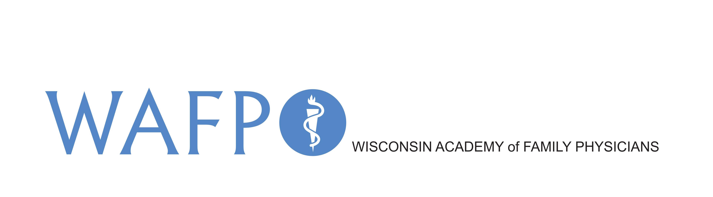
210 Green Bay Rd.
Thiensville, WI 53092
P: (262) 512-0606
E. academy@wafp.org
W: www.wafp.org

Wisconsin Academy of Family Physicians
Board of Directors Self Assessment Policy and Process

The intent of the survey is to determine how satisfied board members are with board processes and how individual members and the board as a whole can be most effective in supporting the organization.

The board self assessment policy and process is intended to help board members:
Reflect on their experience.
Explore how comfortable, enjoyable, and meaningful participation on the board is to the board member.
Understand individual expectations for preparation time, how the meetings are run, and how decisions are made.
Identify different perceptions and opinions among board members about the board’s role.
Identify and remove obstacles to increased board effectiveness.

The survey, while brief, points to issues that need board discussion and clarification. All responses will be tabulated so that the results and comments from the surveys and the interviews will be reported, but not attributed to an individual. Board members and staff will only see the compiled results.

Date policy approved by WAFP Board: 8/27/16
Board Policy Last Revised:

Board Self-Assessment

Mark with an “x” the column that best represents your agreement or disagreement with the statement.
 |  | Strongly agree | Agree | Disagree | Strongly disagree | Not sure or can’t rate
 | I feel the meetings focus on important organizational matters.
 | I am clear about my responsibilities as a member of the board.
 | Materials related to significant decisions are given to the board far enough in advance of the meeting.
 | The amount of material I need to read prior to the meetings is reasonable.
 | It is clear to me how urgent matters are handled between meetings.
 | I feel I have a clear understanding of the mission and activities of the organization.
 | When I was new to the board, I was given sufficient information to allow me to make a contribution to the organization quickly.
 | I receive financial information that is understandable and gives me a clear sense of the organization’s financial position.
 | I receive information about the organization’s services that allows me to understand the impact the organization is having.
 | I feel that I have the information I need to effectively represent the organization to the community and to ask for financial support.
 | There is good follow-up on tasks delegated to me or other board members.
 | I feel that other members listen to my opinions.
 | I feel I can comfortably say when I disagree with another member or with staff.
 | The board gives honest feedback to the executive director.
 | It is clear to me how the board will be involved in important decisions.
 | Board members understand that they do not have authority to act on behalf of the board or the organization unless specified in the bylaws or through a board decision.
 | The board has a clear process for making important decisions.
 | The board has a clear process for making important decisions.
 | The board sets resource development goals and actively supports fundraising and resource development efforts.
 | The board sets explicit performance measures for the CEO/executive director and evaluates performance against these measures.
 | The board’s uses a formal and approved method of ED/CEO performance evaluation.
 | The board sets clear goals that are realistic and relevant to the strategic plan.
The board has the needed skills, diversity, and representation of stakeholders

If you disagree, please describe what skills or characteristics are missing:

 | If a friend or valued professional contact was a good match for the board’s needs, I willing to recruit them.

25. How satisfied are you with the work of the board overall (circle your answer)

VERY SATISFIED SATISFIED NOT SATISFIED

Please list the three areas where you would like to see the board improve its performance focus in the next year. Be as specific as possible.
Please list the three areas where you would like to see the board focus its attention in the next year. Be as specific as possible.

1.
2.
3.
Comments and responses will not be attributed to individual board members.

