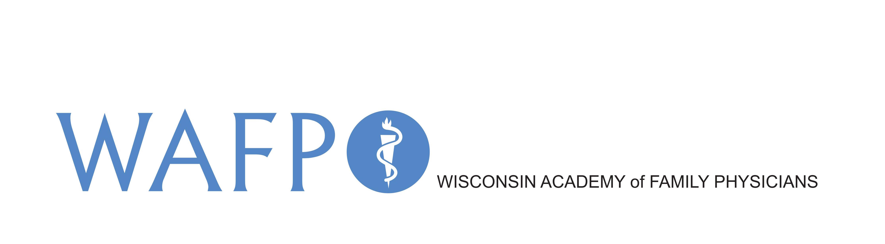
210 Green Bay Rd.
Thiensville, WI 53092
P: (262) 512-0606
E. academy@wafp.org
W: www.wafp.org

Wisconsin Academy of Family Physicians
Board of Directors Attendance Policy

Purpose
This policy is intended to support full contribution of all board members. All board members receive a copy of this official policy. The policy is reviewed once a year and is available in member’s online Board Manual. The policy has been reviewed and authorized by the board.
Definition of a Board Attendance Problem
A board attendance problem occurs if any of the following conditions exist in regard to a board member's attendance to board meetings:
- The member has two un-notified absences in a row (“un-notified” means the member did not call or email ahead to the WAFP office before the upcoming meeting to indicate they would not be in attendance).
- The member has three notified absences in a row.
- The member misses a total of three board meetings in a twelve-month period. (Includes any combination of un-notified or notified absences)
Active participation by phone or webinar is considered attending a meeting.
Action Pending a Board-Attendance Problem
If a board-attendance problem exists regarding a member, the Board Chair will promptly contact the member to discuss the problem. The member’s response will be shared by the Chair with the executive committee at the next executive committee meeting. During that meeting, the executive committee will decide what actions to take regarding the board member’s future membership on the board. If the executive committee decides to terminate the board member’s membership, termination will be conducted per this policy. The executive committee will promptly initiate a process to begin recruiting a new board member.
Date policy approved by WAFP Board 8/27/16
Board Policy Last Revised:

